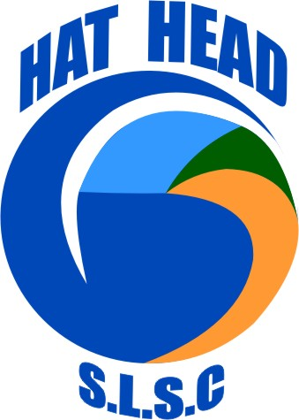Hat Head Surf Club

*Club members are needed to help with the following fundraisers during the Xmas holidays. Any time you can offer is greatly appreciated.* ***All funds raised to directly to our club.***

Boxing Day Trig- *members needed 8.30am onwards to help setting up marshalling tent, first aid & BBQ preparations for bowls.*

Boxing Day Bowls @ Hat Head Bowling Club

Egghead Johnston & Heff Sutherland Memorial Bowls Day

Entry $10 per person. Names due by 1.30pm with 2pm kick off. Prizes for Most Jovial competitor. Dress up if you wish

*Surf club members needed to cook/serve BBQ on a shift basis.*



Family Fun Day 6th January 2019

*@ Hat Head Bowling Club from 4.00pm*

*BBQ *raffles *jumping castle *live band

* face painting

*Members needed from 2.30pm to set up BBQ, shade areas, catering equipment. Members needed to cook/serve BBQ, supervise jumping castle and face painting on a shift basis.*

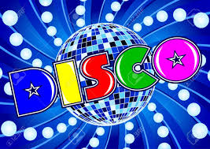

@ Hat Head Bowling Club

each Wednesday in January (2nd, 9th, 16th with 23rd TBC) from 6pm

entry- gold coin donation

*Members needed to collect glow products etc from surf club then setting up at Bowling club from 4.50pm.*  *Help required for glow product sales, collect entry donations, selling raffles tickets. Pack up 8.30pm.*

Members are to wear club shirts to all fundraisers. Come and have a great time!